Registration
$230.00 Provider Course – Healthcare
$255.00 Provider Physicians, DDS
$205.00 Renewal – All
$75.00 AHA Skills Check -Off
Please print: (INFO REQUIRED FOR E-CARD)
Course Date:____________________________
Name:_________________________________
Title (required):__________________________
Address:_______________________________
City:__________State:_____Zip:____________
Cell Phone:_____________________________
Work Phone:____________________________
Employer:______________________________
Email: _________________________________
*Renewal applicants will need to present their Provider card at the door.

Registration:
Email: floresb3@uthscsa.edu
Phone:361-881-8133
Fax: 361-888-7523
Mail:
South Coastal AHEC
ACLS Department
400 Mann Street, Ste 600
Corpus Christi, TX. 78401

Payment:
Credit card: log on to website: www.southcoastalahec.org and use PayPal
Checks: payable to Gulf Coast AHEC ACLS Training Center
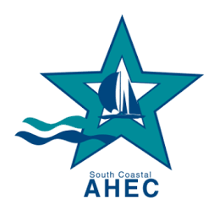
CashApp: $scahec

Gulf Coast AHEC
AHA ACLS Training Center
400 Mann St.,Ste 600
Corpus Christi, TX. 78401

Gulf Coast AHEC

(SOUTH COASTAL AHEC)

ACLS Training Center

Advanced Cardiac Life Support

2024 Course Dates

Provider Course
February 2-3
April 5-6
June 7-8
August 2-3
October 4-5
December 6-7

RENEWAL COURSE
February 3
April 6
June 8
August 3
October 5
December 7

For More information call
361-881-8133

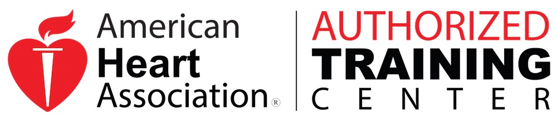
In cooperation with
The American Heart Association
Texas Affiliate.

Advanced Cardiac Life Support

2023 Course Dates

Course Description and Goal
AHA Guidelines for CPR & ECC
The AHA’s ACLS Provider Course has been updated to reflect new science in the AHA Guidelines for CPR and ECC. ACLS teaches the importance of preventing cardiac arrest, high-performance teams, continuous high-quality CPR, systems of care, recognition and intervention of cardiopulmonary arrest, post-cardiac arrest care, acute dysrhythmias, stroke, and acute coronary syndromes (ASC).
The GOAL of the ACLS Provider Course is to improve outcomes for adult patients of cardiac arrest and other cardiopulmonary emergencies through early recognition and interventions by high performance teams.
Course Objectives
In the ACLS Provider Course, the students will learn and practice:
- Systematic Approach (assessment)
- High-Quality BLS
- Airway Management
- Rhythm Recognition
- Defibrillation
- Intravenous (IV)/intraosseous (IO) access (information only)
- Use of Medications
- Cardioversion
- Transcutaneous Pacing
- High-Performance Teams

Course Prerequisites and Preparation
- Pickup and Read the ACLS Provider Manual
- Complete Mandatory Pre-Course Self -Assessment in the ACLS Student Resources (accessed via eLearning.heart.org)
- Pass the Pre-Course Self-Assessment with minimum score of 70%
- Print your Certificate of Completion and bring it with you to the course. Required to attend.
- You will need the following knowledge and skills to complete the course:
  - BLS Skills
  - ECG rhythm interpretation for core ACLS rhythms
  - Knowledge of Airway Management and Adjuncts
  - Practical application of ACLS rhythms and drugs
  - Effective high-performance team skills

Registration Information:
Register by mail using this brochure. All registrations must be guaranteed with payment by check, money order, credit card log on to www.southcoastalahec.org use PayPal Donate button or CashApp.
Enrollment is limited, early registration is encouraged. Make check payable to: Gulf Coast AHEC, ACLS Dept. 400 Mann Street, Ste 600, Corpus Christi, TX 78401
CME-Accreditation:
The Gulf Coast Area Health Education Center is accredited by the Texas Medical Association to sponsor continuing medical education for physicians. GCAHEC designates this educational activity for a maximum of 16 credit hours Provider course in Category 1 credit toward the AMA PRA Category 1 Credit(s)™.
Renewal Course GCAHEC designates this educational activity for a maximum of 8 credit hours AMA PRA Category 1 Credit(s)™.
Physicians should only claim credit commensurate with the extent of their participation in the activity.

The GCAHEC is an ACLS Training Center recognized and accredited by the ACLS Advisory Committee of the American Heart Association. The GCAHEC has been recognized and approved by the American Heart Association as a Training Center.
The American Heart Association strongly promotes knowledge and proficiency in treatment of cardiovascular emergencies and stroke and has developed instructional material for this purpose. Use of these materials in an educational course do not represent sponsorship by the American Heart Association. Any fees charges for such course, except for a portion of fees needed for AHA materials, do not represent income to the Association

This activity has been planned and implemented in accordance with the Essential Areas and Polices of the Texas Medical Association (TMA) through GCAHEC.
The GCAHEC is accredited by TMA to provide
continuing medical education for physicians.

Renewal Course CME
Intensive hands-on experience/shorter course

Nursing Credits
CNE contact hours are not provided

HEARTCODE SKILLS CHECK
Must present AHA Certificate of Completion


Disabilities Act: in compliance with the
Americans with Disabilities Act, all reasonable
efforts to accommodate a person with disabilities
will be made.

Tips for the Course Day:
- Start time: 8am – Arrive early to start on time.
- Full course is 2 days / Renewal 1 day
- Complete Mandatory Pre-Course Assessment It is required
- Food is allowed.
- Dress comfortable.
- Light breakfast provided
- Coffee and water provided
- End time depends on when everyone has passed.
- Any other questions, call 361-881-8133

